RUSTENBURG: 27th JULY – 2nd AUGUST 2003

RED ROUTE

VARIATION = 16W 1KM = 4MM 1NM = 7.4MM
POINT | CLUE | SKETCH
START | CHURCH  25°34.5’S / 27°13.1’E
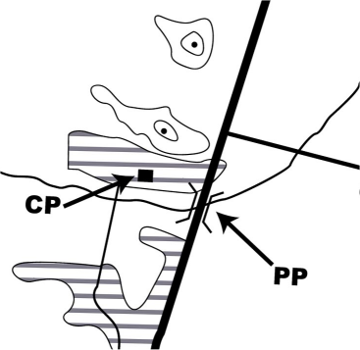  CP1 | PP: ROAD/RIVER CROSSING  12.7km and 237°(T) from CP2  CP: SCHOOL BUILDING  600m and 308°(M) from PP
CP2 | ROAD/RIVER CROSSING  4.7nm and 305°(T) from Trig Beacon (3987) at 25°30.6’S / 27°28.9’E
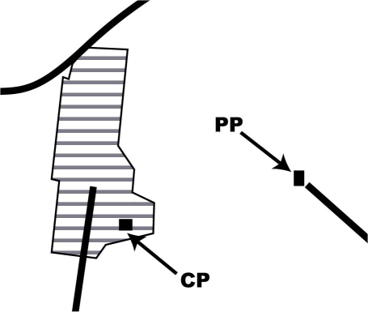  CP3 | PP: FARM BUILDING  5.4nm from CP2 and 18.0km from PP1  CP: SCHOOL BUILDING  1.9km and 271°(M) from PP
CP4 | POWERLINE/ROAD CROSSING  275°(M) to Pilanesberg Airport and 7.0nm from I-Finish
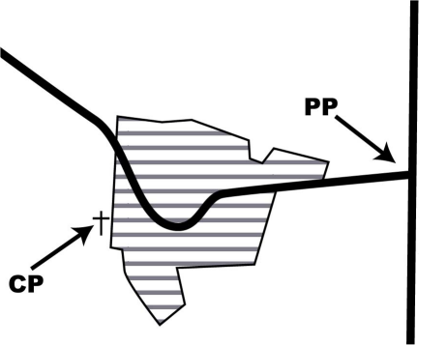  CP5 | PP: ROAD T JUNCTION  5.7nm and 018°(M) from CP4  CP: CEMETARY  3.0km and 262°(T) from PP
CP6 | SPOT HEIGHT (Trig Beacon)  8.6nm to PP10 and 255°(M) to PP5
CP7 | SW END OF AIRSTRIP  3.3nm from Map Grid 25°00’S / 27°30’E and 8.5nm from CP6

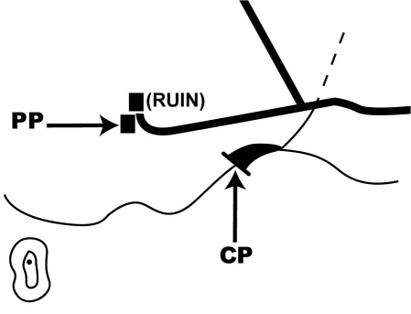  CP8 | PP: FARM BUILDING  21.9km and 231°(M) to CP6  CP: SMALL FARM DAM – CENTRE OF WALL  1.0km and 116°(T) from PP
CP9 | MINE – CENTRE OF QUARRY  2.6nm and 169°(M) from Map Grid 25°00’S / 27°45’E
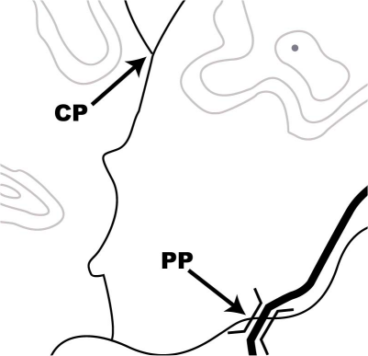  CP10 | PP: ROAD/RIVER CROSSING  29.3km and 077°(T) from PP5  CP: RIVER CONFLUENCE  1.4nm and 352°(M) from PP
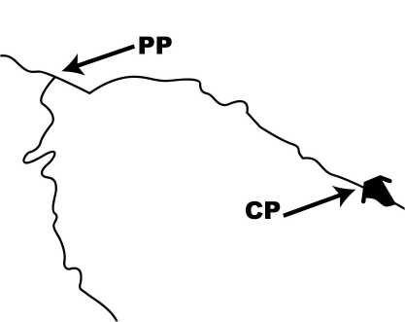  CP11 | PP: RIVER CONFLUENCE  3.2nm from PP10 and 17.5nm to CP4  CP: FARM DAM – CENTRE OF DAM WALL  2.9km and 110°(T) from PP
CP12 | END OF RAILWAY LINE  1200m past Atlanta Railway Station situated at 25°15.1’S / 27°36.8’E
I-FINISH | POWERLINE/RIVER CROSSING  24.0km and 031°(T) from CP2
AWAY LANDING | ALLIED RIVERS LANDING STRIP  1.5nm and 359°(T) to I-Finish (south of Moetwil farm)  RWY 09/27, 3200ft, Freq: 124.8  ! WARNING: See detail Airfield Information Sheet for Away Landing Instructions | Note: Airstrip runs  E-W, not N-S as shown on map
I-START | FARM BUILDING – House with swimming pool  10.3km and 316°(T) from PP15
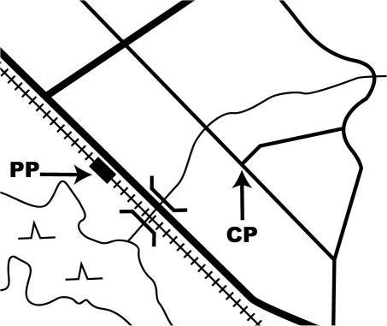  CP15 | PP: RAILWAY STATION  10,9nm from CP12 and 22.8km from CP2  CP: ROAD T JUNCTION  1.2km and 111°(M) from PP

CP16 | MINE – Smoke stack on mine complex  10,8nm and 256°(T) from Brits Airfield
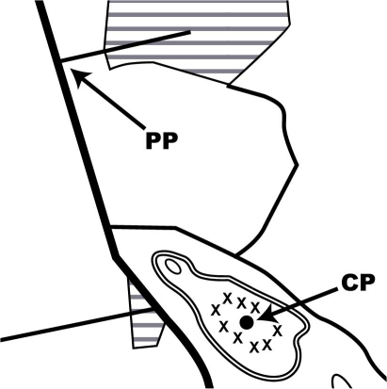  CP17 | PP: ROAD T JUNCTION  7.9nm and 281°(M) from CP16  CP: MINE - CENTRE OF QUARRY  2.9km and 144°(T) from PP
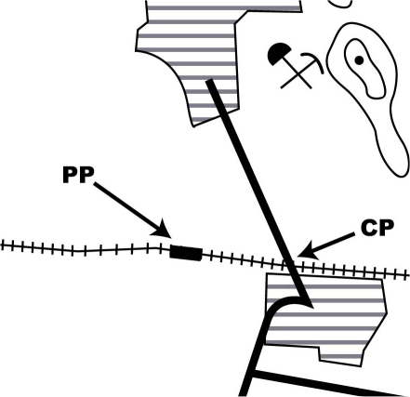  FINISH | PP: RAILWAY STATION  5.5nm from Rustenburg Airfield and 6.7nm from PP17  CP: ROAD/RAILWAY CROSSING  1.0km East of PP along railway line

